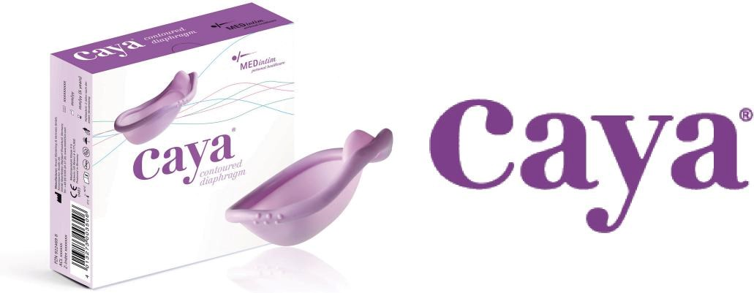

Dear Healthcare Provider:

Your patient has expressed an interest in the all new, "Next Generation", Caya Contoured Contraceptive Diaphragm. It is an RX rated Medical device and therefore will need a prescription. Our product has been developed over the past 10 years with the woman's anatomy in mind. You will see its unique contoured shape that was tested in clinical trials and found to be comfortable, easy to use and effective.
Plus, one size fits most every woman, no need for "traditional fittings"!

We encourage you, when possible, to stock Caya right in your office, ensuring patient access. What a tremendous service and convenience for your patients!

To order Caya for your office, please contact HPSRx customer service for our New Account Application. The application will need to be completed and faxed back along with your state medical license and product order.

If you would like any additional information or FREE "Test Fit" samples, please call our toll-free number or visit our product website at www.caya.us.com. These "test fit" units are a great way to confirm the product fits your patient and that she is comfortable using it. You can prescribe with confidence!

What a wonderful way to help your patients! We thank you for your time and assistance with your customer's request!

Sincerely,
The HPSRx Team

Phone (800) 850-1657 1640 Roanoke Blvd, Salem, VA 24153 customerservice@hpsrx.com

